**Digital Nurture 4.0 Deep Skilling**

**Week 1**

**Exercise 1: Implementing the Singleton Pattern**

**Code :**

**Output:**

**Exercise 2: Implementing the Factory Method Pattern**

**Code :**

**Output :**

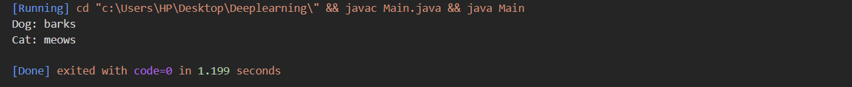

**Exercise 2: E-commerce Platform Search Function**

**Code:**

**

**Output :**



**Exercise 7: Financial Forecasting**

**Code :**

**